PRACTICE PROGRAM(09-08-2024)

1. Find the series of numbers take 10 as input and print the series in reverse order using recursion

import java.util.Scanner;

public class ReverseSeriesRecursion {

public static void main(String[] args) {

Scanner scanner = new Scanner(System.in);

System.out.print("Enter a number: ");

int n = scanner.nextInt();

System.out.println("Series in reverse order: ");

printSeries(n);

}

public static void printSeries(int n) {

if (n > 0) {

System.out.print(n + " ");

printSeries(n - 1);

}

}

}

Output:

Enter a number: 10

Series in reverse order:

10 9 8 7 6 5 4 3 2 1

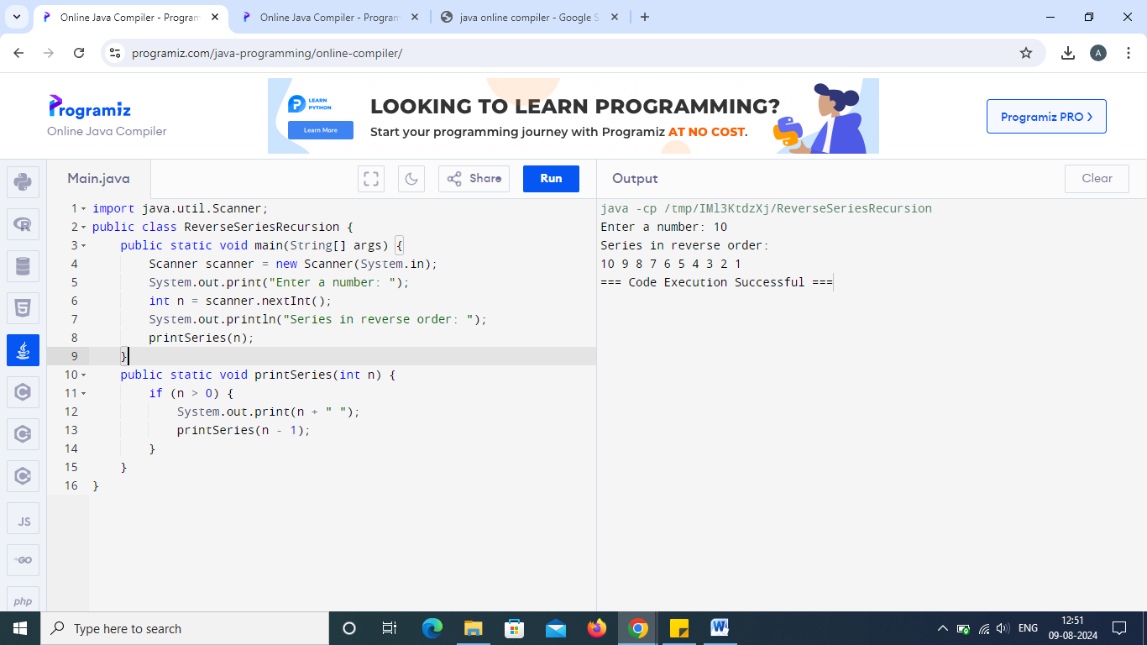

2. Recursive Fibonacci series

public class FibonacciRecursion {

public static void main(String[] args) {

int n = 10; // number of terms in the series

System.out.println("Fibonacci Series: ");

for (int i = 0; i < n; i++) {

System.out.print(fibonacci(i) + " ");

}

}

public static int fibonacci(int n) {

if (n <= 1) {

return n;

} else {

return fibonacci(n - 1) + fibonacci(n - 2);

}

}

}

Output:

Fibonacci Series:

0 1 1 2 3 5 8 13 21 34

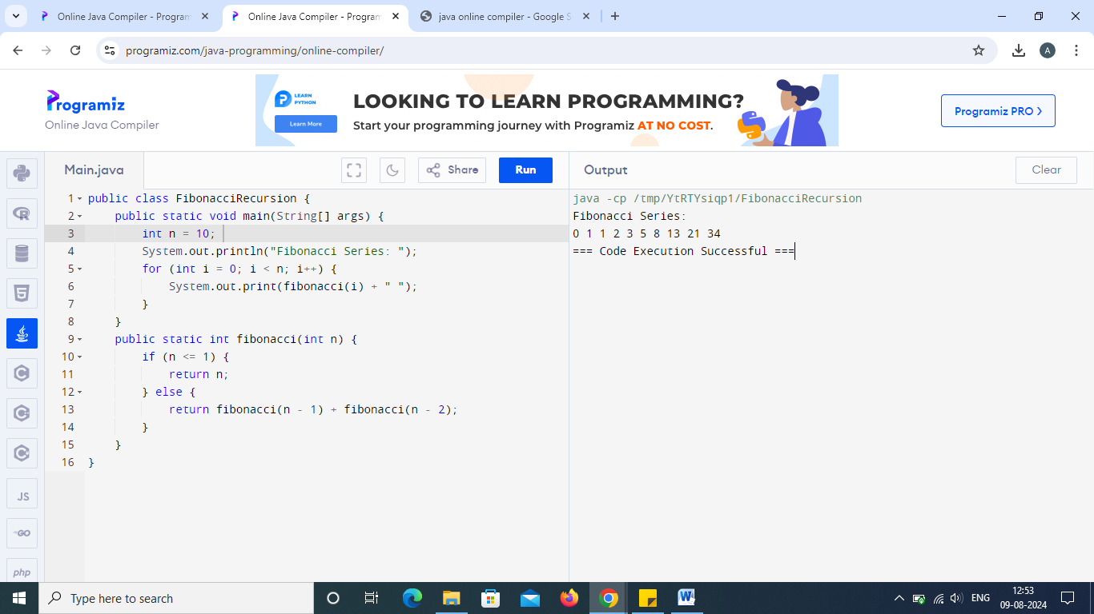

3. Using recursive find the given string is palindrome or not

import java.util.Scanner;

public class PalindromeRecursion {

public static void main(String[] args) {

Scanner scanner = new Scanner(System.in);

System.out.print("Enter a string: ");

String str = scanner.next();

if (isPalindrome(str, 0, str.length() - 1)) {

System.out.println(str + " is a palindrome");

} else {

System.out.println(str + " is not a palindrome");

}

}

public static boolean isPalindrome(String str, int start, int end) {

if (start >= end) {

return true;

} else if (str.charAt(start) != str.charAt(end)) {

return false;

} else {

return isPalindrome(str, start + 1, end - 1);

}

}

}

Output:

Enter a string: madam

madam is a palindrome

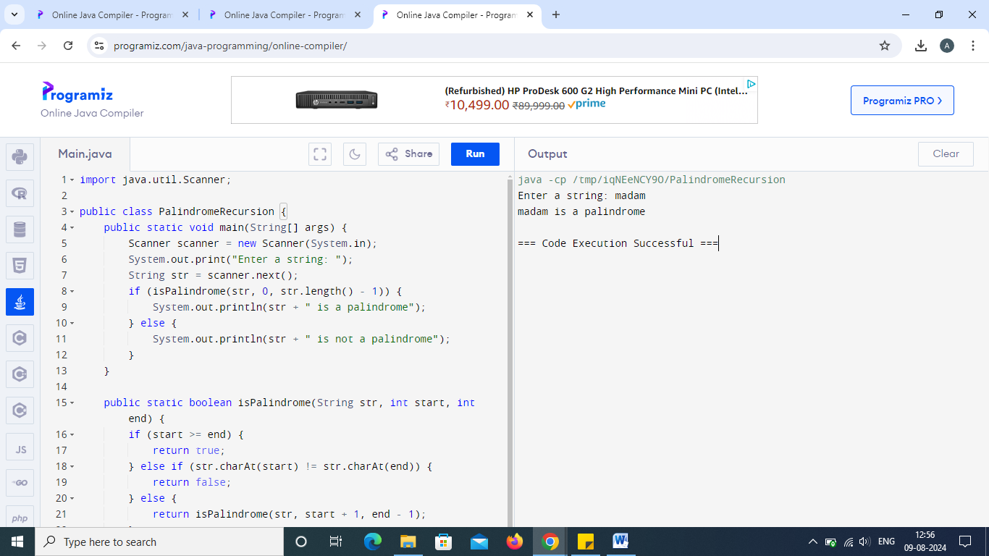

4. Factorial using recursion

public class FactorialRecursion {

public static void main(String[] args) {

Scanner scanner = new Scanner(System.in);

System.out.print("Enter a number: ");

int n = scanner.nextInt();

System.out.println("Factorial of " + n + " is: " + factorial(n));

}

public static int factorial(int n) {

if (n == 0) {

return 1;

} else {

return n \* factorial(n - 1);

}

}

}

Output:

Factorial of 5 is: 120

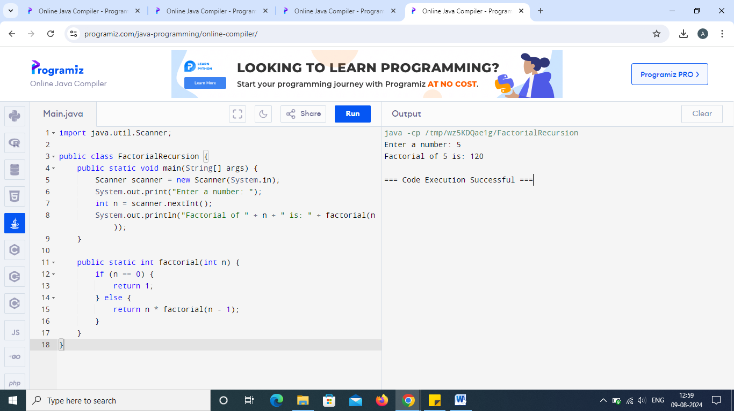

5. Addition of a series using a recursive function:

public class SeriesAdditionRecursion {

public static void main(String[] args) {

int n = 10;

System.out.println("Sum of series: " + sumSeries(n));

}

public static int sumSeries(int n) {

if (n == 0) {

return 0;

} else {

return n + sumSeries(n - 1);

}

}

}

Output:

Sum of series: 55 